Digital Nurture – 4.0 JAVA FSE – Week 6 Assignments

File name: 1. ReactJS-HOL

Name: Hands-on in this document

App.js

import React from 'react';

function App() {

  return (

    <div>

      <h1>Welcome to the first session of React</h1>

    </div>

  );

}

export default App;

Output;

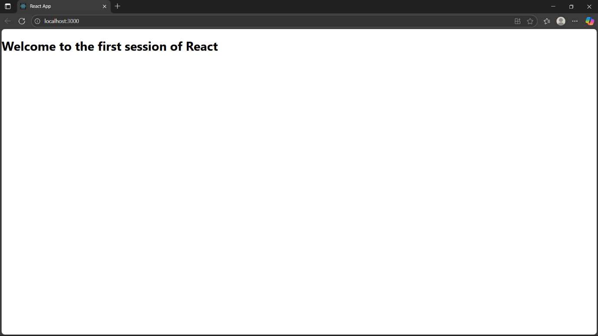

File name: 2. ReactJS-HOL

Name: Hands-on in this document

About.js;

import React from 'react';

function About() {

  return (

    <div>

      <h2>Welcome to the About page of the Student Management Portal</h2>

    </div>

  );

}

export default About;

Contact.js;

import React from 'react';

function Contact() {

  return (

    <div>

      <h2>Welcome to the Contact page of the Student Management Portal</h2>

    </div>

  );

}

export default Contact;

Home.js;

import React from 'react';

function Home() {

  return (

    <div>

      <h2>Welcome to the Home page of Student Management Portal</h2>

    </div>

  );

}

export default Home;

App.js;

import React from 'react';

import Home from './components/Home';

import About from './components/About';

import Contact from './components/Contact';

function App() {

  return (

    <div className="App">

      <Home />

      <About />

      <Contact />

    </div>

  );

}

export default App;

Output;

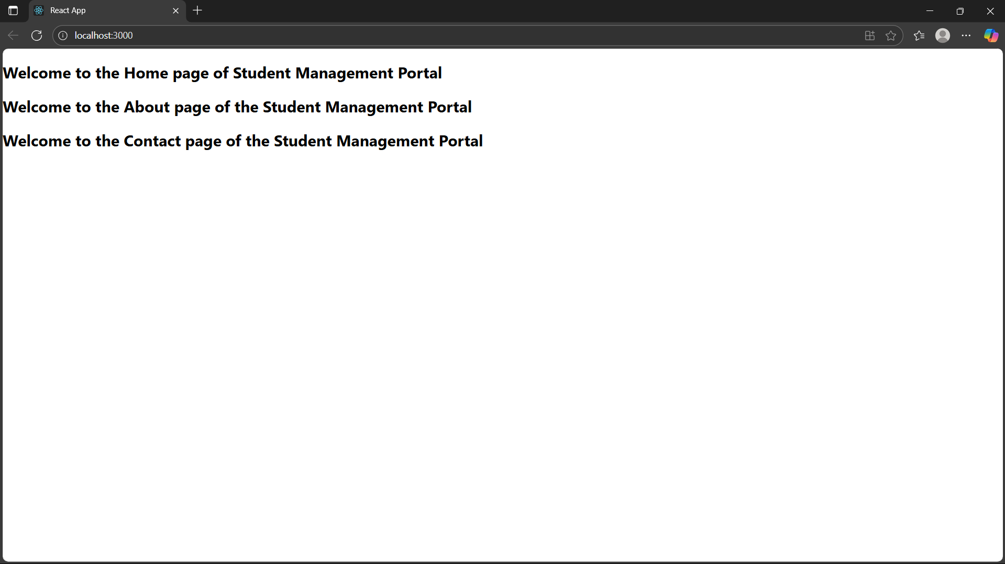

File name: 3. ReactJS-HOL

Name: Hands-on in this document

CalculateScore.js;

import React from 'react';

import '../Stylesheets/mystyle.css';

function CalculateScore() {

  const name = "Lalit Kishore";

  const school = "ABC Public School";

  const total = 450;

  const goal = 500;

  const average = (total / goal) \* 100;

  return (

    <div className="score-card">

      <h2>Student Score Calculator</h2>

      <p><strong>Name:</strong> {name}</p>

      <p><strong>School:</strong> {school}</p>

      <p><strong>Total Marks:</strong> {total}</p>

      <p><strong>Goal:</strong> {goal}</p>

      <p><strong>Average Score:</strong> {average.toFixed(2)}%</p>

    </div>

  );

}

export default CalculateScore;

mystyle.css;

.score-card {

  margin: 30px auto;

  padding: 20px;

  width: 50%;

  border: 2px solid #333;

  border-radius: 10px;

  background-color: #f0f8ff;

  font-family: Arial, sans-serif;

  box-shadow: 2px 2px 8px rgba(0,0,0,0.2);

}

.score-card h2 {

  color: #003366;

  text-align: center;

}

App.js;

import React from 'react';

import CalculateScore from './components/CalculateScore';

function App() {

  return (

    <div className="App">

      <CalculateScore />

    </div>

  );

}

export default App;

Output;

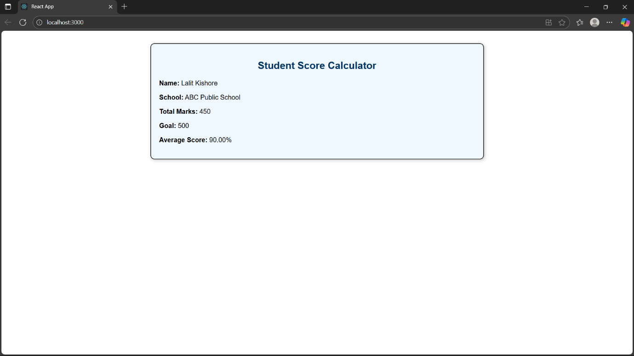

File name: 4. ReactJS-HOL

Name: Hands-on in this document

Post.js;

// src/Post.js

import React from 'react';

class Post {

  constructor(userId, id, title, body) {

    this.userId = userId;

    this.id = id;

    this.title = title;

    this.body = body;

  }

}

export default Post;

// src/Posts.js

import React, { Component } from 'react';

import Post from './Post';

class Posts extends Component {

  constructor(props) {

    super(props);

    this.state = {

      posts: []

    };

  }

  loadPosts = () => {

    fetch('https://jsonplaceholder.typicode.com/posts')

      .then(response => response.json())

      .then(data => {

        const postList = data.map(item => new Post(item.userId, item.id, item.title, item.body));

        this.setState({ posts: postList });

      })

      .catch(error => {

        console.error('Error fetching posts:', error);

        alert('Error fetching posts');

      });

  };

  componentDidMount() {

    this.loadPosts();

  }

  componentDidCatch(error, info) {

    alert('An error occurred: ' + error);

  }

  render() {

    return (

      <div>

        <h1>Posts</h1>

        {this.state.posts.map(post => (

          <div key={post.id}>

            <h2>{post.title}</h2>

            <p>{post.body}</p>

          </div>

        ))}

      </div>

    );

  }

}

export default Posts;

App.js;

import React from 'react';

import './App.css';

import Posts from './Posts';

function App() {

  return (

    <div className="App">

      <Posts />

    </div>

  );

}

export default App;

Output;

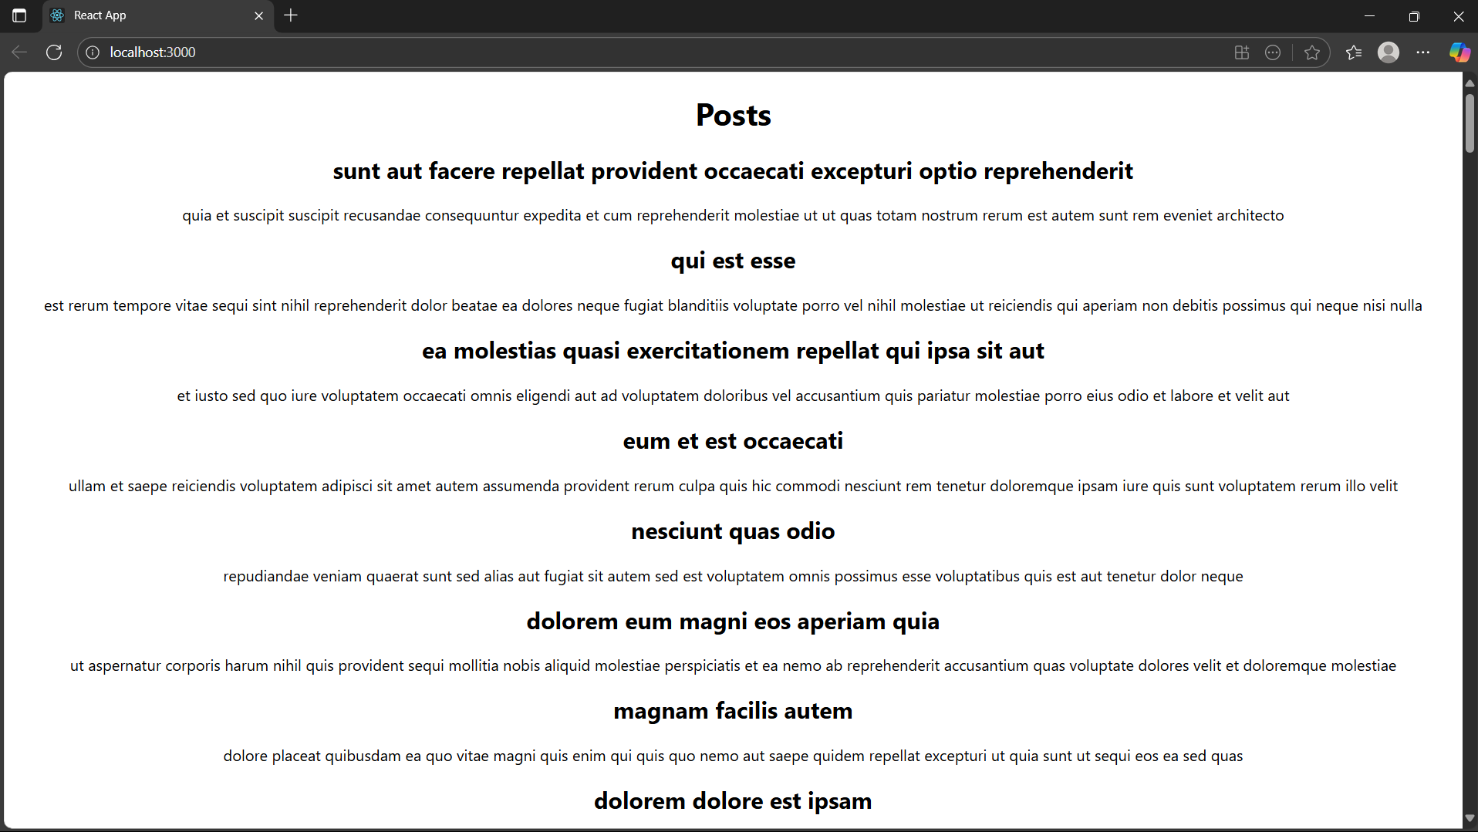

File name: 5. ReactJS-HOL

Name: Hands-on in this document

CohertDetails.js;

import React from 'react';

import styles from './CohortDetails.module.css';

function CohortDetails({ name, status, startDate, endDate }) {

  const headingStyle = {

    color: status === 'ongoing' ? 'green' : 'blue',

  };

  return (

    <div className={styles.box}>

      <h3 style={headingStyle}>{name}</h3>

      <dl>

        <dt>Status:</dt>

        <dd>{status}</dd>

        <dt>Start Date:</dt>

        <dd>{startDate}</dd>

        <dt>End Date:</dt>

        <dd>{endDate}</dd>

      </dl>

    </div>

  );

}

export default CohortDetails;

App.js;

import logo from './logo.svg';

import './App.css';

import { CohortsData} from './Cohort'

import CohortDetails from './CohortDetails';

function App() {

  return (

  <div>

    <h1>Cohorts Details</h1>

    {CohortsData.map(cohort => <CohortDetails cohort={cohort}/>)}

  </div>

  );

}

export default App;

Output;

